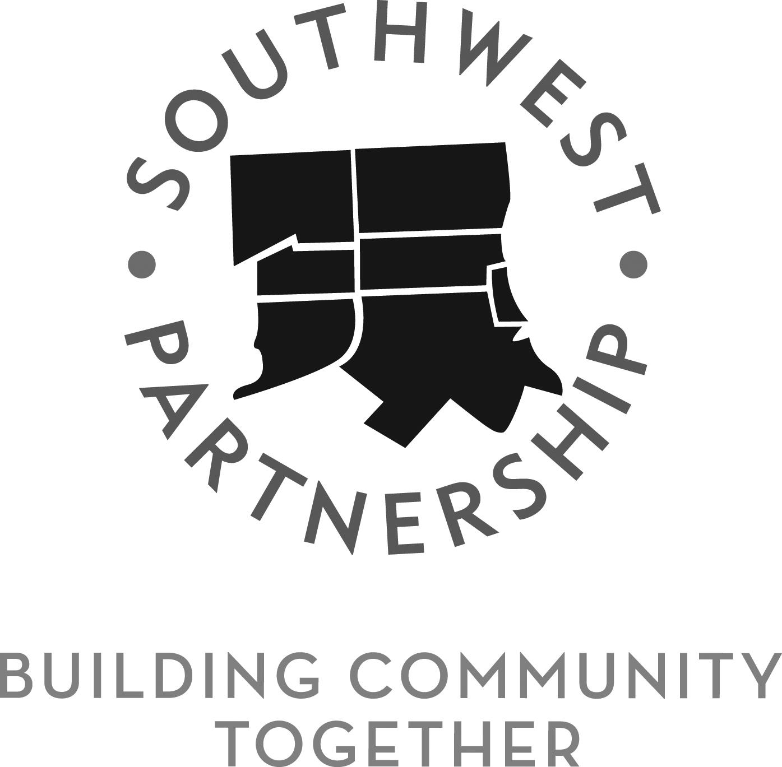

Board of Directors Meeting
MINUTES
August 16, 2016 7:15 pm
870 W. Baltimore Street, Baltimore, MD

- In Attendance —

Richard Parker
Khandra Sears
George Kleb
Scott Kashnow
Daniel Morrison
Dorothy “Dotie” Page
Justin Parker
Nancy McCormick
Ashley Valis
Beverly Jacobs
Robert “JR” Lee
Leonard Taylor
Lisa Rawlings
William “Bill” Marker
James “Jamie” Pitts
Jane Shaab
Stacy Smith
Bishop Edna Isaac
Tammy Seag
Shirley Bryant
Clottell Davis
Hakim Ali
Troy Stanton
Marian Green
Shirley Minor
Nancy Littlepage
Valerie Clarke
Jane Buccheri
Lou Packett

Bif Browning
Vernell Lewis
Yvonne Gunn
Cynthia Mason
Ray Winbush
Dan Coleman
Eugene Balbierz
Michael Seipp
Schlonte McGee
Elizabeth Weber
Catherine Neely
Daniel Rodenburg
Ramon Luna
Del. Antonio Hayes
Sonia Eaddy

Board Members Not in Attendance
Christopher Redwood

Introductions
Guests introduced themselves

Approval of Minutes
The minutes from the June 2016 meeting were approved with no edits.

Note: No treasury report provided at the meeting.

Executive Director Report (Michael Seipp)
There was a request to review, update, and clarify the state funding that is and has become available to the SWP. Before giving the report Michael recognized Del. Hayes and the other members of the Baltimore state delegation who put together a Baltimore package to benefit Baltimore’s neighborhoods. Most of the money approved by the legislature will be available in July of 2017.

There are three programs that the SWP needs to pay attention to:
- Project CORE: will have the most funding over 3 years for the demolition of vacant structures; to assemble land or buildings for development; site development; and architectural and engineering work directly related to demolition, site development, or stabilization of a building. There are 18 million dollars available this year. It is intended to make land/buildings ready for development.

- Baltimore Regional Neighborhoods Initiative: this year there are 3 million dollars available; next year there will be 12 million dollars to go to community based development organizations and activities that further the development and revitalization of a community. Projects that are near RAD developments, such as Hollins House, or anchor institutions will receive extra points. To be eligible for BRNI organizations need to have a vision or community plan in place. The SWP applied to be BRNI eligible this year, and particularly next year will be able to compete for funding.

- Community Legacy Program: has been around for a long time, provides smaller grants for specific, concrete activities and is generally capital orientated.

There is a fourth program is for anchor institutions—Seed Community Development Anchor Institution Fund for development activities within the community which abuts the anchor institution. It is available for private as well as public anchor institutions (universities and hospitals).

The resolutions approved at the last board meeting relate to the three funding sources to which SWP can apply; those applications are already in, and the CORE applications are due August 19th. The biggest one for CORE is the lease-to-purchase development in Franklin Square and Mount Clare.

Scott Kashnow: Will we hear about the funding decisions?

Response: A team came out today to look at the sites the big one for physical development is the 1000 block of W. Fayette St with HomeFree USA. By mid-September the review team is planning to send recommendations to the governor's office, but it is still unknown when the final announcement will be made.

Committee Reports
Education and Workforce Development (Lisa Rawlings)
The Committee partnered with the UMB Office of Community Engagement to hold a YouthWorks program at the Community Engagement Center; had 13-14 students working on neighborhood initiated projects. Went well, students developed bonds with mentors and many want to work on community project. Committee is also working with the Friends of Carroll Park and the Chesapeake Center for Youth Development on a youth baseball league in Carroll Park.

Due to funding from the Local Development Council for the Casino Impact Area Southwest Works will be a partnership between the Mayor’s Office of Employment Development and the SWP. A MOED employee will be working full time in the SWP area working with residents to connect them to workforce development resources. They will be at 3 community sites: CEC, SWP, and Clay Pots, other two days will be at the Employment Connection Center at 1401 Bush St. Bon Secours Community Works is already a MOED site so almost all workforce providers will be able to access one database of folks who are looking for work. This person will also be point of contact for anchor institutions looking to hire locally.

Also received support from LDC for attendance monitor program for the three schools in Pigtown. The program is run by Public Allies out of the UMB School of Social Work and will hire community members who have been identified by the schools.

One of the earliest action items was that every school will be a community school—James McHenry will be a community school in the fall, but under the current model will be decades before each school will be a community school. The Committee is partnering with LeaderComm to train community members in organizing around schools. First workshop will be Saturday August 20th, 9-12 at SW Baltimore Charter School 1300 Herkimer St.

There were 3 days of service completed at James McHenry and Franklin Square and Steuart Hill. Close to 20 volunteers at Franklin Square, 20 at Steuart Hill, James McHenry had about 10. Also gave away corn and tomatoes at three different schools. Profiles helped the events be covered in the Sun and on TV. Lou Packett organized the days at James McHenry and Franklin Square and JR Lee organized the day at Steuart Hill.

Richard Parker wanted to recognize that the funding from the LDC came through Del. Hayes’ Committee, and will make a tremendous impact in the area.

Safe Vibrant and Walkable Streets
Chris Redwood was not present so Elizabeth gave the attached report. Scott Kashnow added that Parks and People is doing a water quality project in Franklin Square Park along the sides of the park.

Public Safety (JR Lee)
Held a Bike Rodeo on July 17th to teach kids bike safety and make sure that the understood proper safety. Had 25 kids who participated and received a certificate and free bike helmets from Bikemore.

The Committee is mapping alleys for gating to create defensible spaces. Gates would be locked with a code so that they would be accessible by homeowners and emergency services and residents. JR needs to talk to Mount Clare and Pigtown community members about their allies.

The Committee is starting a Community In-Control initiative they want to control crime and grime in the community by using cameras to identify people having a negative impact/committing crimes/dumping.
George Kleb commented that he has seen this strategy has worked in the past.

Gates have been put up in the past and they have been taken away.

Ashley Valis: One of the YouthWorks students who was placed at the Community Engagement Center was shot as a bystander in Poppleton after his service. The family is holding a blood drive tomorrow (8/17/2016) at Shock Trauma in honor of him from 8am-1:30pm at the W. Lombard and Greene St. entrance.

Historic Preservation (Scott Kashnow):
Still moving forward with projects, sign projects moving forward, have applications in for funding.

There was a demolition hearing scheduled for the house on W. Baltimore and S. Schroeder that has been bumped until October. The house has been approved for demolition pending the approval of a landscape design.

Yvonne Gunn asked about the landscape design.

Dan Morrison will scan it and send it to her. There were questions about what requirements there were for the plan. Scott doesn’t know.

Bif Browning encouraged community members to attend the meeting, has been told that CHAP will come to speak to the community and he hasn’t heard anything. Jane S asked if the community treasured the building and if it would be worth moving. In Hollins Roundhouse the neighborhood is very attached to the arch may be less attached to the building if it is not the only example of what it is in the neighborhood.

Jane Buccheri: the building does have a rich history. Approval to demolish came due to the financial hardship of demolition rather than the history.

Bill Marker suggested a partnership with UM College Park to investigate the history of the building. Jane and Ashley can definitely pursue it.

The committee is planning an event to collect historical information and stories from neighbors to collect the stories of the neighborhoods and connect people to each other. It is hoped this will be the beginning of a series of small events held quarterly around the neighborhoods. The event is being planned for October or November. Will be recording through video, audio, photos, and digitizing photographs.

Housing (Jamie Pitts)
Wanted to acknowledge that Vernell Lewis had Day of Fun at James McHenry Elementary through the Hollins Roundhouse Neighborhood Association.

Last Housing Committee meeting had two hours of debate at last meeting. Talked about the scope and direction of the committee. Also there has been a lot of rumors about development in the community and encourages people not to react to rumors without considering the source. The committee’s goals are moving forward. They have selected a developer for the Franklin Square and Mount Clare community projects. Other goals are to identify focus areas in other neighborhoods and develop a resource guide.

Bishop Isaac mentioned that her church, New Testament Missionary Baptist Church, owns property on W. Baltimore and N. Mount St. and has been trying to do good work in the community for decades. They have faced a lot of oppositions and exclusion in trying to develop the neighborhood, and feel as though their projects have been unfairly blocked by the city and others. She is excited about being able to work with the SWP.

Commercial Development (Stacy Smith)
Also had a spirited community meeting, believes that development in the area is coming to culminating point.

The committee approved supporting the Poppleton Plan, and to support raising the initial $500,000, and supporting the LuvsArt project and block party around Hollins Market. Goal is that there needs to be one picture for the community that celebrates everybody.

Stacy Smith began presenting the ‘Poppleton Transition District: A Prepared Vessel “For the Promoting of People” ’ which she stated was meant to fill in the gaps of what was missing in other plans. The mission of the plan is to create education, industry, and housing opportunities for transitional residents and small businesses to partake of opportunities that are being built in Southwest Baltimore. Goals include projects to support traditionally marginalized people and people of color in education, workforce development, business development, housing, and historic preservation. Stacy stated that she had met with hundreds of people and 58 churches in developing the plan.

Richard Parker asked why the goals of the plan were not worked through the relevant SWP committees. He is confused about why the Commercial Development Committee is working on other committee’s topics. Stacy Smith stated that the people she spoke to weren’t favorable about the SWP and her position is that she can bring their ideas to the SWP.

Khandra Sears asked what was the purpose of meeting with people about their ideas and concerns if those concerns weren’t shared?

Lisa Rawlings and Jamie Pitts both requested that the ideas and concerns related to their committees be shared with them.

Richard Parker stated that based on time and the length of the presentation it would be unable to be completely presented at this meeting.

Dotie Page stated that she is the Poppleton representative, and lives in Poppleton, and this is the first time she has heard of the Poppleton Transition Plan; stated that she has been attending Poppleton meetings all year.

Daniel Coleman stated that the only way to understand the plan would be to hear it in its entirety.

Richard Parker clarified that the Southwest Partnership does have a unified Vision Plan for the area, but that individual neighborhoods have their own as well.

Sonia Eaddy lives in Poppleton and heard about the SWP meetings when she was approached and had begun attending meetings both for the neighborhoods and for the Housing Committee, and has been coming to the meetings about what needs to happen in Poppleton. She helped put together the plan of what is happening in Poppleton and would like the plan heard.

Jane Shaab is very interested in the presentation but thinks that the presentation was mislabeled as a commercial development report rather than a Poppleton neighborhood association plan, thinks it should have been a separate agenda item and topic.

Richard Parker said that the plan will be presented separately at the next meeting. Stacy asked if it could be a separate meeting, but that would need to be scheduled.

Old Business
Trade name filing has been completed.

Community Announcements
Richard Parker read the community announcements and events which have been updated to the SWP calendar at http://southwestpartnershipbaltimore.org/events/

The meeting was adjourned 9:18pm.

